1. Create a function module to import a range of customer numbers and export the customer data for the given range.

Customer Data can be found in table KNA1.

Time : 30 minutes

Create a package and keep all objects created for this task in that package.

Paste screenshots of all the objects created for this task.

**PACKAGE: ZLA_PACKAGE**

**FUNCTION MODULE:** ZLA_FM_MATERIAL

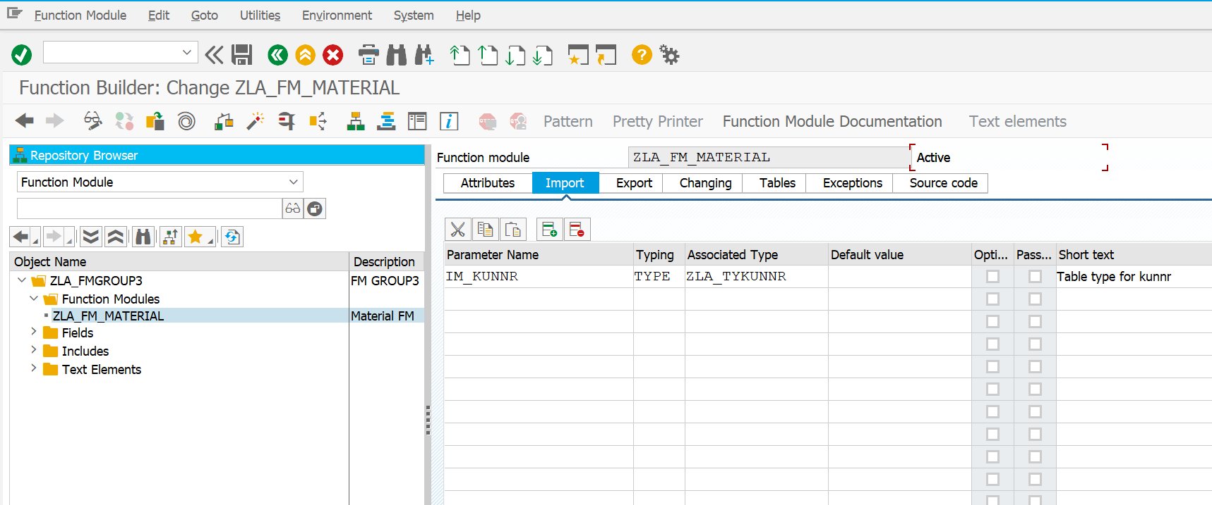

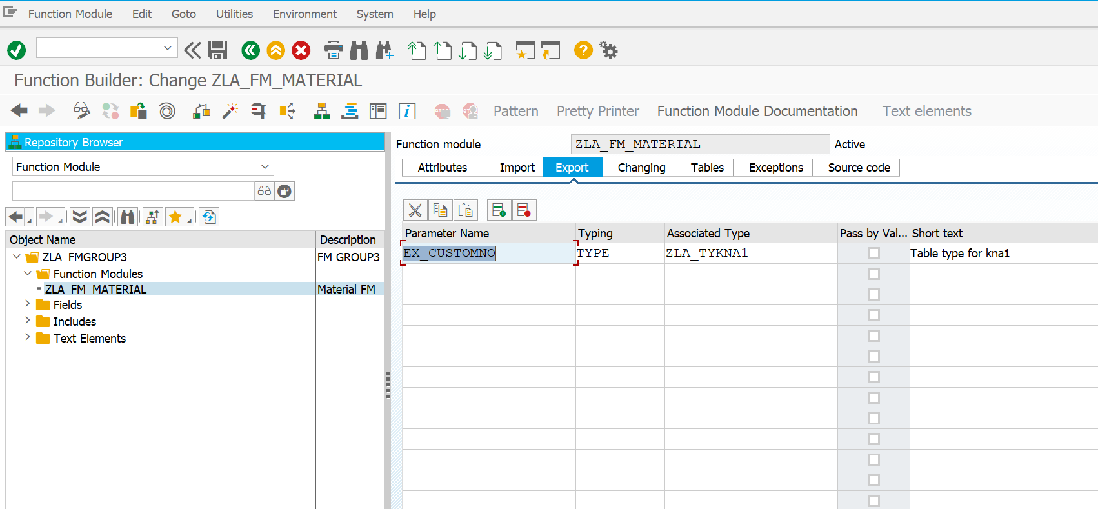

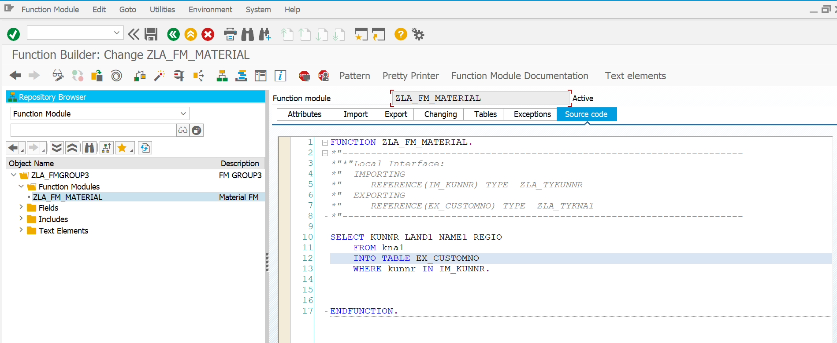

**CODE: ZLA_ASSIGNMENT1**

*\*&---------------------------------------------------------------------\**  
*\*& Report ZLA_ASSIGNMENT1*  
*\*&---------------------------------------------------------------------\**  
*\*&*  
*\*&---------------------------------------------------------------------\**  
REPORT ZLA_ASSIGNMENT1.  
 DATA :IT_KNA1 TYPE ZLA_TYKNA1,  
 WA_KNA1 LIKE LINE OF IT_KNA1.  
  
  
 DATA v_kunnr type kunnr.  
  
*\*data v_kunnr type zla_tykunnr-v_kunnr.*  
  
SELECT-OPTIONS s_kunnr FOR v_kunnr.  
  
 perform get_data.  
 perform display_out.  
*\*&---------------------------------------------------------------------\**  
*\*& Form get_data*  
*\*&---------------------------------------------------------------------\**  
*\*& text*  
*\*&---------------------------------------------------------------------\**  
*\*& --> p1 text*  
*\*& <-- p2 text*  
*\*&---------------------------------------------------------------------\**  
FORM get_data .  
CALL FUNCTION 'ZLA_FM_MATERIAL'  
 EXPORTING  
 im_kunnr = s_kunnr[]  
 IMPORTING  
 EX_CUSTOMNO = it_kna1  
 .  
  
ENDFORM.  
*\*&---------------------------------------------------------------------\**  
*\*& Form display_out*  
*\*&---------------------------------------------------------------------\**  
*\*& text*  
*\*&---------------------------------------------------------------------\**  
*\*& --> p1 text*  
*\*& <-- p2 text*  
*\*&---------------------------------------------------------------------\**  
FORM display_out .  
  
 WRITE : /'Cust_No',  
 20 'Country',  
 30 'Name',  
 55 'Region'.  
  
LOOP AT it_kna1 INTO wa_kna1.  
  
  
  
  
 WRITE:/ wa_kna1-kunnr,  
 20 wa_kna1-land1,  
 30 wa_kna1-name1,  
 55 wa_kna1-regio.  
  
 ENDLOOP.  
ENDFORM.

**OUTPUT:**

